

Luis Carlos Guevara
Faculty of Finance,
Government and International Relations

2026-I

Notes on the
installation and use of Zotero
Data analysis

What is Zotero?
Zotero is a reference manager. It is designed to store, manage, and cite bibliographic references such as books and articles. In Zotero, each of these references constitutes an item. More broadly, Zotero is a powerful tool for collecting and organizing information and research sources, and for structuring literature review projects.
- Each item in Zotero contains different metadata, depending on the type of item. Items may include books, articles, reports, web pages, artworks, films, letters, manuscripts, sound recordings, invoices, court cases, statutes, and many others.
- Items appear in the central panel of Zotero. The metadata of each item is displayed in the right panel. This metadata includes titles, creators, editors, dates, page numbers, and any other information needed to cite the item. This allows you to have a complete and organized view of all relevant details of each item, making it easier to manage and reference your research sources.
Installation Process
Where to install Zotero?
Windows | https://www.zotero.org/download/client/dl?channel=release&platform=win-x64&version=7.0.11
MacOS | https://www.zotero.org/download/client/dl?channel=release&platform=mac&version=7.0.11
After installing Zotero, you must install its browser connectors. The Zotero browser connector helps capture bibliographic information directly from your browser.
- When you find a relevant source, such as an academic article, a book in a digital library, or a webpage, you can use the connector to automatically save item details to your Zotero library.
Where to install the Zotero browser connector?
Edge | https://microsoftedge.microsoft.com/addons/detail/nmhdhpibnnopknkmonacoephklnflpho
Chrome | https://chrome.google.com/webstore/detail/ekhagklcjbdpajgpjgmbionohlpdbjgc
Mozilla | https://www.zotero.org/download/connector/dl?browser=firefox&version=5.0.151
Safari | The Zotero connector for Safari is included with the Zotero installation for Mac. It can be enabled from the Extensions panel in Safari settings.

After installing Zotero, you must install its Word processor plugin. Among the different ways to automatically generate bibliographies (as well as in-text citations and footnotes), word processor plugins are the most powerful and easy to use. These plugins, available for Microsoft Word, LibreOffice, and Google Docs, create dynamic bibliographies: when you insert a new citation into your manuscript, the bibliography will automatically update to include the cited item.
Where to install the Zotero plugin for Word?
Windows | The word processor plugins are included with Zotero and should install automatically for each compatible word processor on your computer when you launch Zotero for the first time.
MacOS
General Overview of the Zotero UI
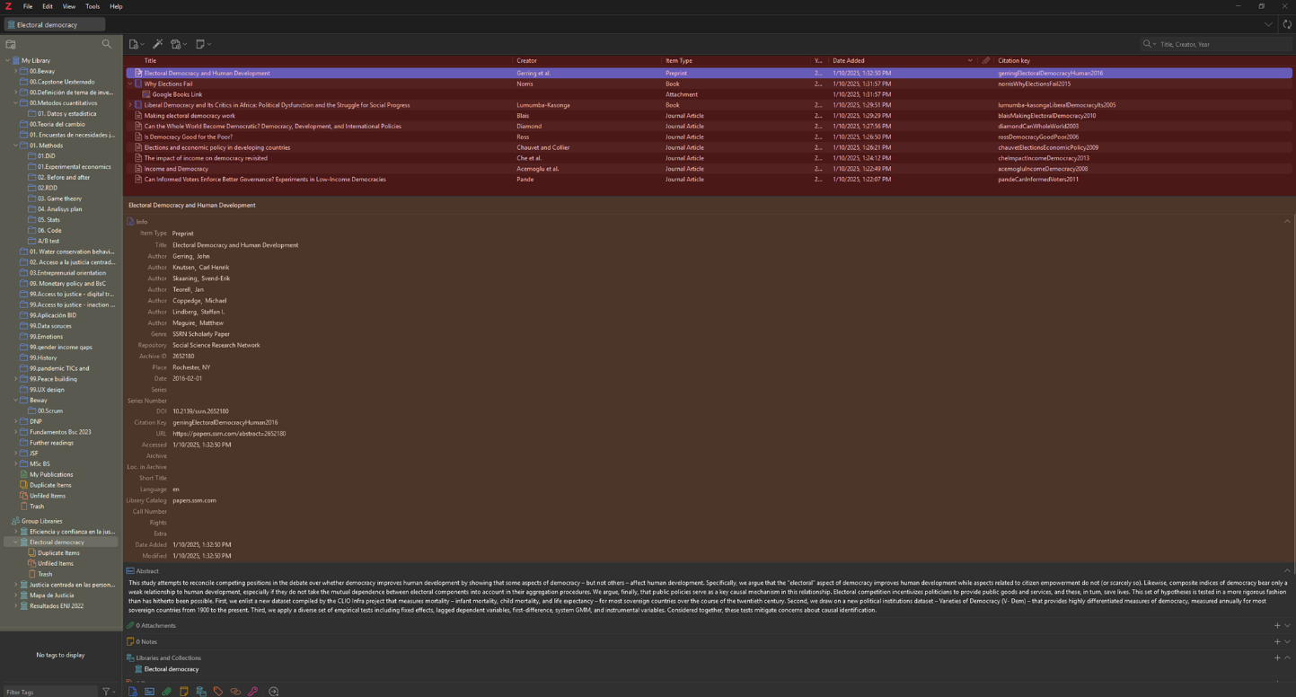
The central panel displays the list of items within the selected folder. In the image, you can see details such as titles, creators, item types, and dates added. This view gives you an overview of all references stored in a specific collection.

The central panel displays the list of items within the selected folder. In the image, you can see details such as titles, creators, item types, and dates added. This view gives you an overview of all references stored in a specific collection.

The lower central panel shows the detailed information of the item selected in the central panel. In the image, you can see the item “Electoral Democracy and Human Development”, with details including title, authors, item type, abstract, and other relevant metadata. This panel allows you to view and edit the specific information of each reference

Using Zotero in Word
Citations
You can start citing with Zotero by clicking the “Add/Edit Citation” button in the Zotero menu. When you press the button, the citation dialog will appear.
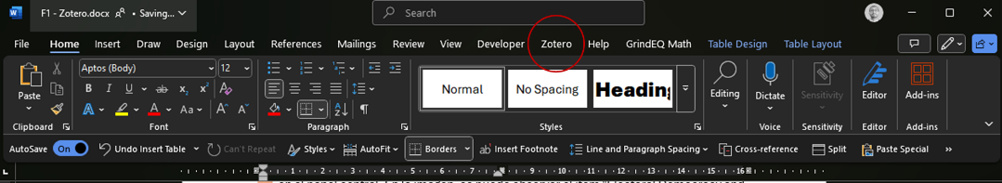 | 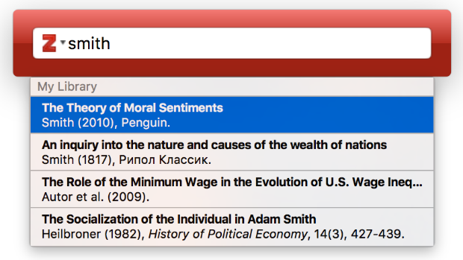

The citation dialog is used to select items from your Zotero library and create a citation. To do this:
- Start typing part of a title, the surname of one or more authors, and/or a year in the search box. Matching items will instantly appear below the dialog.
- Matching items will appear for each library in your Zotero database (“My Library” and any groups you belong to). Items already cited in the document will appear at the top of the list under “Cited.”
- Select an item by clicking on it or pressing Enter when it is highlighted. The item will appear in the dialog inside a shaded bubble. Press Enter again to insert the citation and close the “Add Citation” dialog.
In the “Add Citation” dialog, you can click on the bubble of a cited item and then click “Open in My Library (or Group Library name)” to view it in Zotero. Items that are orphans (not connected to anything in your Zotero database) will not have an “Open in My Library” button.

Bibliography
When you click the “Add/Edit Bibliography” button, a bibliography is inserted at the cursor location. As you use the plugin, Zotero will automatically update the bibliography based on the citations included in the document.
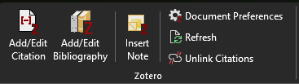
If you need to add items to the bibliography that you have not cited in the document, you can click the “Add/Edit Bibliography” button again to open the bibliography editor. Manual edits made directly in Word will be overwritten the next time Zotero updates the document.
Additionally, Zotero allows you to choose from a wide variety of citation styles to adapt your bibliography to the specific requirements of academic publications or institutions. If you need even more customization, you can use the citation style editor to adjust it as needed.

